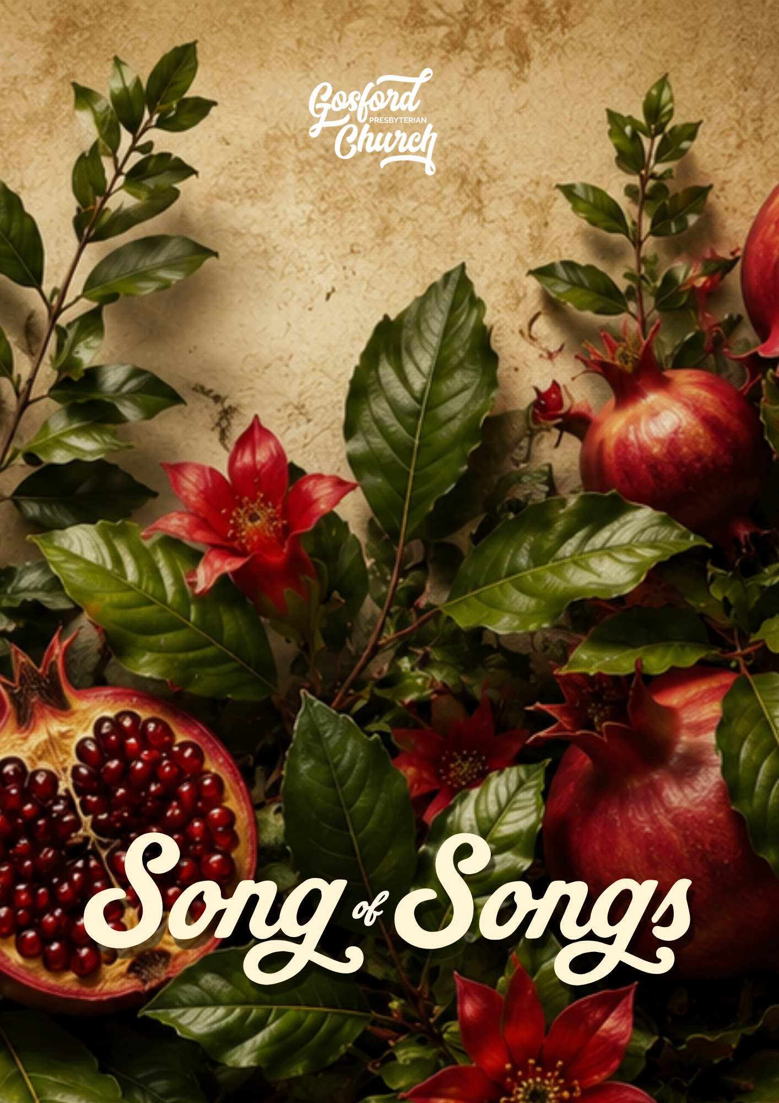
Introduction
“We should be amazed that our Savior chose to describe his relationship with his church with a parable of such exquisite pleasure.” John Piper
This book is part of the Bible's collection of wisdom literature. It is presented as a love poem between a husband and wife. The book is sometimes referred to as Song of Solomon, and was most likely written during his reign (c. 971–931 BC). The author writes about sexual intimacy, desire, friendship, and wisdom in romantic relationships. It can be read as both an expression of physical and emotional desire, and as an allegory of God's love and longing for His people.

Where Song of Songs is seen as simply allegorical, it should be noted that Solomon would not use sin to signify the relationship between God and His bride. In a sense, it is even more striking if it is allegorical that Solomon would use such graphic, sexual language to think of our relationship with God. Such a perspective neither blunts or lessens the remarkable sexual implications for husband and wife, because it is used in reference to God. Where taken as an allegory, you too have a remarkable explicitness about what is in the bedroom of a godly man and wife.
The Song of Songs confronts us with the challenge not just of literary allegory, but of life allegory. This is the main thing. It calls us to look into and through the physical pleasures of sex, both in Solomon’s song and in our bedroom. It is not just that this song is really about physical reality and also points to something spiritual in relationship to God and the church, but that life is physical and points to something spiritual.
In other words, the literary sex and the real sex are both allegorical. God didn’t just give us the Song of Songs to show us something of his love. He gave us sex to show us something of his love.
Studies prepared by Jamie Mackenzie.

Free Commentary:
Scan the code or visit
www.thegospelcoalition.org/commentary/song-of-solomon/

Study Methods:
In diving into the Song of Songs, we are putting forward two possible methods to promote wrestling with and studying the text. Choose the one that suits you best.
The first method is to work through the guided studies using the questions provided in this booklet.

The second method is the Swedish method, outlined overleaf. You'll find space for your notes using this method at the end of each study.

The (Adapted) Swedish Method
The Swedish method is a common, easy to do Bible reading or study method. It can be done in small groups, one to one Bible reading groups or even by yourself as a personal devotion method. The great strength of the Swedish Method (and why we are giving it as an option here at GPC) is it forces and encourages us to wrestle with the Bible passage itself. Like wringing a sponge, it encourages us to get as much sustenance as we can from it. Each person has the opportunity to discover for themselves what God says.


A Light Bulb: This should be something that ‘shines’ from the passage—whatever impacts you the most, or draws your attention. Something that stands out or strikes you. (There is no right or wrong)

‘I really found this interesting…’
‘I really love this verse…’

A Question Mark: Anything that is difficult to understand in the text, or a question you might like to ask the writer of the passage.

‘I’m not sure what this means…’
‘I’m not really sure how this works…’
‘How does this play itself out…’

A Vertical Arrow: How does this passage, stir our/challenge your affections about God. How is this a challenge to your thinking, your loves/desires or your perceptions of your relationship with God etc.

‘I tend to really struggle with believing this….’
‘I’ve never really considered God in this way…’
‘I tend not to think like this…this passage really encourages me in…’

Either write one thing next to each item or get ready to discuss as a group each section. (This might need a few minutes of silence).
Afterwards, in the first round share one of your ‘light bulbs’ with the group, there is no right or wrong. Spend some time discussing these, if your group is keen; it’s always interesting to discover what has impacted different members and why.
Then, in the second round, share a question that might be raised by the passage.
In the third round, share how does this passage point us to Jesus. Scripture always has implications and applications for us. Sometimes this will reframe our loves/desires. Consider what are the implications for your own life.

Study 1 Song of Songs 1:2-2:7

A Snapshot of What’s Ahead:
The book opens with a celebration of the beauty of romantic love as a good gift from God. We see a collection of poems between two lovers, with the invitation and observations of their friends. The poems capture incredible delight, admiration, commitment, and purity. The lovers delight in honouring one another with their words and are marked by commitment, mutual affection and possession.
Intro:
What are different pictures/images/allegories that the church or other cultures use to help people understand God? What do those images seek to convey?

Read: Song of Songs 1:2-2:7
- Who speaks most in this dialogue?

- How does the woman describe her feelings toward her beloved?

- Is there any embarrassment or shame in her expression of love? How would you describe her language?

- What insecurities does she express? How do insecurities affect relationships?

- What are some common distortions that people have around sex/intimacy in either the world or the church?

- How does this passage challenge those distortions?

- What is the warning given at the end? Who is it given to?

Read: Ephesians 5:25-32
- How does marriage point us toward Christ? If this poem is also an allegory for Christ and His bride, how might this challenge or shape the way we perceive God?

- How does God's view of us challenge our insecurities?

- What difference does being deeply known make?

Pray:
Pray for link missionary Cathryn Chawla serving with Mark Drama Australia.
Pray for SRE classes in Wyoming and Valley View Public Schools.

Song of Songs 1:2-2:7

_____________________________________________________________
______________________________________________________________________________
______________________________________________________________________________
_____________________________________________________________
_____________________________________________________________
_______________________

_____________________________________________________________
_____________________________________________________________
______________________________________________________________________________
_____________________________________________________________
_____________________________________________________________
_______________________

_____________________________________________________________
_____________________________________________________________
______________________________________________________________________________
______________________________________________________________________________
_____________________________________________________________
_______________________

Study 2 Song of Songs 2:8-17

A Snapshot of What’s Ahead:
In this passage, we find the joy and anticipation of committed love, to understand the importance of responding wisely to love, and to identify the "little foxes" that can damage relationships with God and others.
Intro:
What's something you've been excitedly waiting for recently?

Read: Song of Songs 2:8-17
- What emotions dominate this passage?

- What images stand out?

- Throughout Scripture, God is the one who moves toward his people.
- God seeks Adam and Eve after the Fall.
- God rescues Israel from Egypt.
- Christ comes into the world to save sinners.
How does the picture of the eager bridegroom in this passage challenge your picture of God?

- Do you view your relationship with God primarily as duty or as a relationship initiated by his love?

- How does knowing that Christ pursues his people encourage you when you are feeling weary, or despondent?

- What invitation does the beloved give?

- How does he describe the season around them?

- Why might the changing season be significant?

- Vs15 speaks of ‘foxes that ruin the vineyard’. Why might little foxes be dangerous? What might the foxes represent?

- What are some "little foxes" or “socially acceptable foxes” that damage friendships, marriages, families, or churches?

  - Going deeper: How do these ultimately rob us of joy, and intimacy in our relationships with each other and/or with God?

Read: Song of Song 2:16-17
- What confidence do you hear in these words?

- What makes this relationship secure?

- How does commitment deepen joy?

- How does belonging to Christ provide security during difficult seasons?

Pray:
Pray for our link missionary Sally Trethewy, working with Scripture Union NSW.
Pray for SRE classes in Narara Public School and Niagara Park Public School.
Song of Songs 2:8-17

_____________________________________________________________
______________________________________________________________________________
______________________________________________________________________________
_____________________________________________________________
_____________________________________________________________
_______________________

_____________________________________________________________
_____________________________________________________________
______________________________________________________________________________
_____________________________________________________________
_____________________________________________________________
_______________________

_____________________________________________________________
_____________________________________________________________
______________________________________________________________________________
______________________________________________________________________________
_____________________________________________________________
_______________________

Study 3 Song of Songs 3:1-5

A Snapshot of What’s Ahead:
In this passage, fear and anxiety enter into the picture. Some wonder whether this is a dream, regardless explore the themes of longing, searching, finding, and reunion. Giving reflections on the challenges we face in relationships no longer in Eden.
Intro:
Have you ever lost something important and searched everywhere for it—what was it like when you finally found it (or didn’t)?

Read: Song of Songs 3:1-5
  - What emotions dominate this passage?

  - Some think that verses 1-5 tell the story of a dream, do you agree/disagree? Why?

  - What changes from the beginning to the end?

  - How would you describe the woman's journey?

  - How would you describe their reunion?

  - Why does the warning in vs5 appear again?

  - What has the woman learned about love through this experience?

  - Why is patience an important part of love?

  - How can we cultivate patience and trust?

  - In verse 5, the woman speaks to/cautions the other women in her life. How do we go about speaking, or giving advice to the women/men in our life about relationships? Why or why not do you find this difficult?

  - Human relationships are fraught with insecurity and fear at possible loss or rejection. Imagine you have a friend who is struggling with the same insecurities, anxieties and fears with their relationship with God. With either your own experience or Scripture how would you council/encourage/support them?

Pray:
Pray for our link missionary organisation the Bible Society.
Pray for SRE classes in Lisarow and Ourimbah Public Schools.
Song of Songs 3:1-5

_____________________________________________________________
______________________________________________________________________________
______________________________________________________________________________
_____________________________________________________________
_____________________________________________________________
_______________________

_____________________________________________________________
_____________________________________________________________
______________________________________________________________________________
_____________________________________________________________
_____________________________________________________________
_______________________

_____________________________________________________________
_____________________________________________________________
______________________________________________________________________________
______________________________________________________________________________
_____________________________________________________________
_______________________

Study 4 Song of Songs 3:6-5:1
A Snapshot of What’s Ahead:
This passage is one of the high points of Song of Songs. It moves from the anticipation of the wedding (3:6–11), to the groom's celebration of his bride (4:1–15), to the consummation of their marriage (4:16–5:1). Marital intimacy is celebrated as a good gift from God without embarrassment or crudeness. We see how marriage is a joyful covenant celebrated publicly, enjoyed privately, and designed to reflect Christ's covenant love for His people.
Intro:
What makes a wedding memorable?

Why do you think weddings are such significant events across almost every culture?

Read: Song of Songs 3:6-5:1
- How would you describe in your own words what is taking place?

- What details make this feel like a royal celebration?

- Why are so many people involved? Why does God place marriage in the context of public promises?

- How is marriage different from simply living together?

Read: Song of Songs 4:1-15
- What stands out about the way he speaks?

- How is this different from how our culture often talks about beauty?

- It has been said, ‘Healthy love notices. Healthy love encourages. Healthy love speaks life.’ How do these verse challenge you with your words?

- How does the gospel shape the way Christ sees His people?

Read: Song of Songs 4:16-5:1
- Why does God connect sex with exclusivity?

- Why is exclusivity a gift rather than a restriction?

- How does our culture view sexual boundaries differently?

- What surprises you about this picture of intimacy?

- What does this teach about mutuality?

- Why is it significant that Scripture celebrates physical intimacy rather than merely tolerating or permitting it?

- What does this teach us about how God feels when He unites himself to us?

Pray:
Pray for our link missionaries Matt and Mel Crocker as they serve at Grace Presbyterian Church in Wallsend.
Pray for SRE classes in Point Clare Public School and Kariong Public School.

Song of Songs 3:6-5:1

_____________________________________________________________
______________________________________________________________________________
______________________________________________________________________________
_____________________________________________________________
_____________________________________________________________
_______________________

_____________________________________________________________
_____________________________________________________________
______________________________________________________________________________
_____________________________________________________________
_____________________________________________________________
_______________________

_____________________________________________________________
_____________________________________________________________
______________________________________________________________________________
______________________________________________________________________________
_____________________________________________________________
_______________________

Study 5 Song of Songs 5:2-6:3

A Snapshot of What’s Ahead:
After the joy of the wedding and consummation (3:6–5:1), the couple experiences conflict, distance, and renewed pursuit. Rather than presenting an idealised marriage without problems, this section reminds us that love is sustained not simply by passion but by perseverance.
Intro:
Why do small misunderstandings sometimes become big conflicts?

Why is it often easier to avoid difficult conversations than to have them?

Read: Song of Songs 5:2-6:3
- Here in the second dreamlike sequence things are less than perfect. What are some of the shortfalls, or potential problems on display?

- Why does the bride/wife hesitate to respond to her beloved?

- How would you describe the role of the friends in this section? What does that teach us about the role of friends in our own lives/marriages?

- How might we better cultivate such friendships and spaces? Where have you seen this done well?

- Verses 10-16 the bride reflects on her beloved. How does reflective gratitude reshape our perspective? Again, how might we better cultivate such practices?

- Read together:
- Ephesians 4:26–32
- Colossians 3:12–15
- Matthew 18:21–35
What principles for reconciliation do these passages teach?
How do they complement Song of Songs?

- The good news is that Jesus is not a reluctant Bridegroom.
Read:
- John 10:27–29
- Luke 15:3–7
How do these passages encourage us when we feel distant from God?

Further Questions for Reflection:
- How do you currently handle conflict?
- Are you learning healthy habits of repentance and forgiveness?
- Have you allowed busyness or familiarity to dull your affection?
- Do your conversations focus more on faults or gratitude?
- What practical steps could those who are married take to intentionally pursue their spouse?

Pray:
Pray for link missionaries Rick and Tracey Rempel, serving with MAF in Canada.
Pray for SRE classes in Gosford and East Gosford Public Schools.
Song of Songs 5:2-6:3

_____________________________________________________________
______________________________________________________________________________
______________________________________________________________________________
_____________________________________________________________
_____________________________________________________________
_______________________

_____________________________________________________________
_____________________________________________________________
______________________________________________________________________________
_____________________________________________________________
_____________________________________________________________
_______________________

_____________________________________________________________
_____________________________________________________________
______________________________________________________________________________
______________________________________________________________________________
_____________________________________________________________
_______________________
Study 6 Song of Songs 6:4-8:4
A Snapshot of What’s Ahead:
This section forms the final major movement of the Song before its conclusion. Following the conflict and reconciliation of 5:2–6:3, the couple's relationship is strengthened rather than weakened. The repeated theme is that mature love delights, remains secure, and continues to grow. The refrain at 8:4 ("Do not arouse or awaken love until it so desires") signals the end of this central section of the book and reminds us that love flourishes when enjoyed according to God's timing and design.
Intro:
What traits do you feel cultivate security and strength in a relationship?

Read: Song of Songs 6:4-8:4
- How would you describe the husband’s words/posture towards his wife?

- Walk through each of the images he calls to her – 6:4-9, 7:1-9 – What is he seeking to communicate?

- How is biblical celebration of beauty different from objectification? Or is it?

- What is the bride/lovers response?

- What does our culture often confuse with genuine intimacy?

- Mature love continues to admire, to appreciate, to celebrate. How might we better express admiration, appreciation and celebrate those whom we are in relation with? (Either romantic or platonic)

  - If we find ourselves disheartened because we feel we don’t receive this kind of appreciation, admiration, celebration, what ought we to do?

- Mature love continues to admire, to appreciate, to celebrate. How might we better express admiration, appreciation and celebrate the God whom we are in relation with?

- If the husband is also illustrative of God and how he pursues and views us His church/bride. How do these verses challenge your perception of Him/His perception of you?

- Why does familiarity often reduce appreciation?

- What helps admiration grow instead of fade?

- This section concludes once again with the warning to not arouse or awaken love until the right time. Why does this refrain appear again?

What does it teach about:
- dating?
- sexual intimacy?
- emotional commitment?
Why is waiting an act of wisdom rather than deprivation?

Pray:
Pray for link missionaries Rick and Kayleen Manton, serving in Indigenous Ministry with APWM.
Pray for SRE classes in Somersby and Central Mangrove Public Schools.
Song of Songs 6:4-8:4

_____________________________________________________________
______________________________________________________________________________
______________________________________________________________________________
_____________________________________________________________
_____________________________________________________________
_______________________

_____________________________________________________________
_____________________________________________________________
______________________________________________________________________________
_____________________________________________________________
_____________________________________________________________
_______________________

_____________________________________________________________
_____________________________________________________________
______________________________________________________________________________
______________________________________________________________________________
_____________________________________________________________
_______________________
Study 7 Song of Songs 8:5-14

A Snapshot of What’s Ahead:
Song of Songs 8:5–14 is the fitting conclusion to the book. It gathers together its major themes—covenant love, exclusivity, perseverance, purity, longing, and hope—and ends with a note of anticipation rather than finality. The love celebrated throughout the Song is shown to be powerful, costly, and enduring. At the same time, the ending points beyond earthly marriage to the greater hope of Christ's return and the marriage supper of the Lamb.
Intro:
How would you say our culture describes ‘love’?

Or
Look up some lyrics from popular songs that speak of love – how does that compare or contrast with what we have seen in Song of Songs?

Read: Song of Songs 8:5-14
- The passage opens with the bride and her loving coming up from the wilderness. Why might the wilderness be significant? What might this be communicating?

- How do trials strengthen healthy relationships? Why is dependence sometimes a sign of maturity rather than weakness?

- How is love described in vs5-7?

- Where does/in what ways does human love fall short of these verses and other pictures presented in this book?

- What does the friends comparing their sister to a wall communicate?

- Discuss, what is the place of good friends, in protecting one another’s purity – in marriage or singleness? Why might we struggle to do this/what are obstacles or barriers?

- The woman is the first to speak in Song of Songs, the last to speak and the one who speaks most. How does this challenge our perceptions of relationships, love, sex, intimacy?

- How has this series challenged your view on love, sex, intimacy and marriage?

- How has this series challenged your view on friendships?

- How has this series challenged your picture of God and His relationship with us?

Pray:
Pray for our link missionary organisation Langham Partnership.
Pray for SRE classes in Kulnura and Peats Ridge Public Schools.

Song of Songs 8:5-14

_____________________________________________________________
______________________________________________________________________________
______________________________________________________________________________
_____________________________________________________________
_____________________________________________________________
_______________________

_____________________________________________________________
_____________________________________________________________
______________________________________________________________________________
_____________________________________________________________
_____________________________________________________________
_______________________

_____________________________________________________________
_____________________________________________________________
______________________________________________________________________________
______________________________________________________________________________
_____________________________________________________________
_______________________

Knowing Jesus, Loving People, Changing Lives

Vs13 ‘Shulammite’ – The meaning of this word is unclear. Some say it was the name of the young bride. Others say it is a variant of Shunammite and tells us that she came from Shunem, a village near Jezreel. Still others maintain Shulamite is a feminine form of Solomon, meaning a woman belonging to Solomon.

